
FEST Research Group

Final Year Project Weekly Report Log

(To be completed by Student)

S.No | Student Name: | Student ID:
 | Muhammad Umar | 36682
 | Muhammad Bilal Qamar | 35985
 | Adeel Arshsd

Project Title: Rakhwala (child security system)

Dr Mansoor Ebrahim
Supervisor:
Report Week: Date:

Planned Work
Achievements
Merge all the Arduino based code and test it accordingly .

Successfully tested arduino based code.here is the repository

https://github.com/MuhammadBilalQamar/Rakhwala-Child-Security-System/tree/master/Ardiuno
FEST Research Group

Proposed work
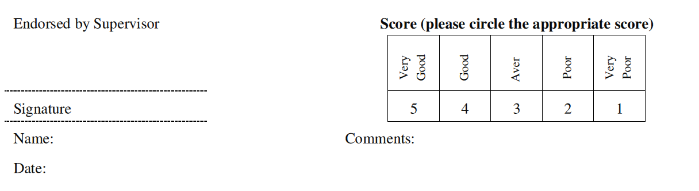
Integrate Ardunio with android app

